Dear Residents of Palmetto Point,

Please Visit [www.palmettopointassociation.com](http://www.palmettopointassociation.com) to view and interact with the new website.

Recent Palmetto Point developments:

Draft meeting minutes for March 7, 2022 board meeting at 4810 Griffin Blvd, Fort Myers, Florida called to order at 7:00 am. EST. A quorum was present. Attendees: Beverly Simmons, Bill Ganzer, and Catherine Coval.

* The proxy letters have been sent out and you should have received them. If you have not, please contact Catherine Coval at [ccovalgo@gmail.com](mailto:ccovalgo@gmail.com) and she will email you one.
* **The annual meeting** and election of board members is set for **March 27th at 1PM** at the vacant lot on the waterfront **4831 Griffin Blvd**. It is at the same place we had it last year. Meeting will last about an hour. We have a **food truck** for after.
* If you are interested in volunteering to be on the board, this is the time to do so.
* Did you know we have a Facebook page now?! Yes, please check it out! https://www.facebook.com/PalmettoPointFM
* 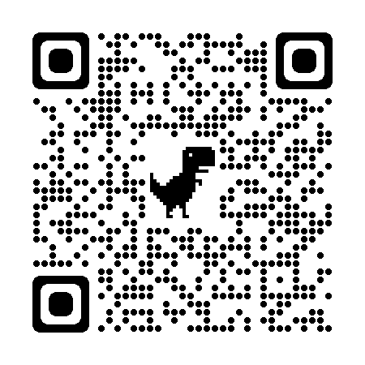
* **Annual dues** can be paid by check in the amount of **$250.00** made out to Palmetto Point Association, and sent to John D Ingraham Treasurer 6758 Griffin Blvd Fort Myers, FL 33908 or by Pay Pal as directed by the Web Site. Pay Pal has a $5.00 Service charge. Checks are preferred, but will accept either form of payment.
* The meeting was adjourned at 8:00 pm.

Thank you to all who have paid your dues. To pay your dues, please visit the website and click on the dues link located on the top right-hand side of the home page.

The Board and the ARC will continue to work on your behalf to ensure Palmetto Point remains the premier waterfront community in Southwest Florida.

Regards,

Palmetto Point Board Members